

Programmed Name: **BCS**

Course Code: **CSC 1013**

Course Name: **System Analysis and Design**

Internal Examintaion

Date**: 9/20/2020**

**Submitted By: Submitted To:**

Student Name: **Dipesh Tha Shrestha** Name: **YOGENDRA BAHADUR MAHATA**

Section: **A**

Semester: **second**

Intake:**2019 September**

1. Data flow diagram is a diagram to illustrate movement of data between external entities and the processes and data stores within a system. Refer to the scenario given below in order to answer questions (a) and (b). AiRIS Wholesale Paper Co. is an established wholesale paper warehouse wants to computerize its sales, inventory and customer billing systems. The warehouse buys its stock directly from the paper manufacturer in packages of very large sheets of paper. It cuts and sells packages of smaller paper sizes to various printer and stationers. The wholesaler's sales people brings purchase orders from the customer to the warehouse and give them to the stock clerk. The clerk checks first to see if the order can be satisfied with offcuts (paper ends left over from previous orders after cutting). If no suitable offcuts are available, the clerk sends a stock handler to retrieve new stock from the warehouse shelves. Once the appropriate stock has been collected together, the stock clerk sends it to the paper cutter who trims it to the desired dimension. Any useable offcuts are returned to the stock clerk in case they can be used for subsequent purchase orders. The cutter sends the trimmed stock to the shipping clerk who checks to see if the order has been satisfied correctly. If there are any problems, the shipping clerk sends the trimmed stock back to the stock clerk who correctly filled order, it is given to the truck driver for delivery, and the purchase order is sent to accounting for appropriate billing
2. Draw a context- level data flow diagram for AiRIS wholesale Paper Co.

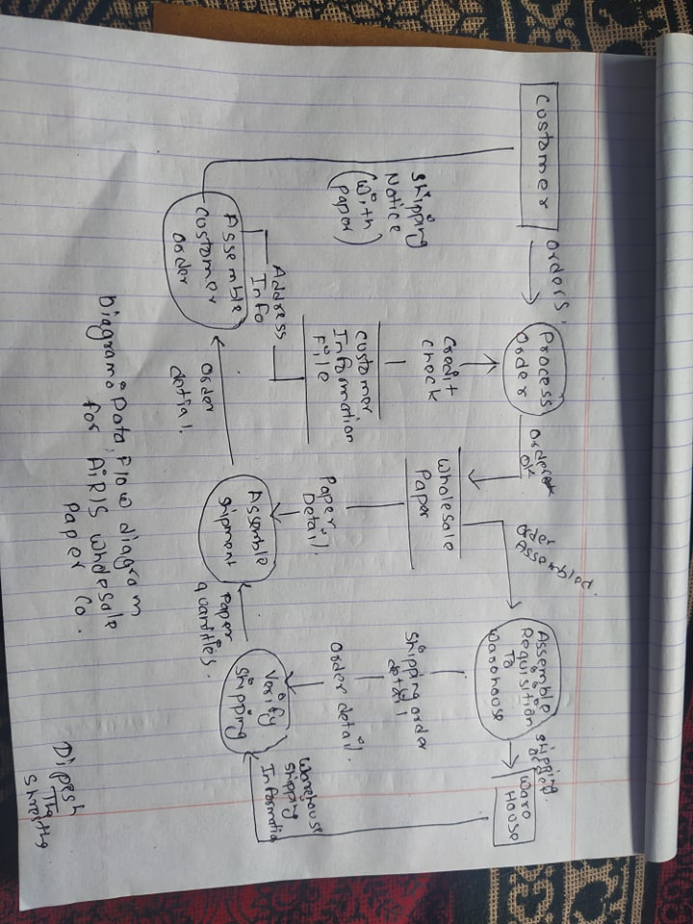

1. Explore the context -level data flow diagram in (a) showing all the major processes called as level 0 diagram. Draw a level 0 diagram for AiRIS Wholesale Paper Co

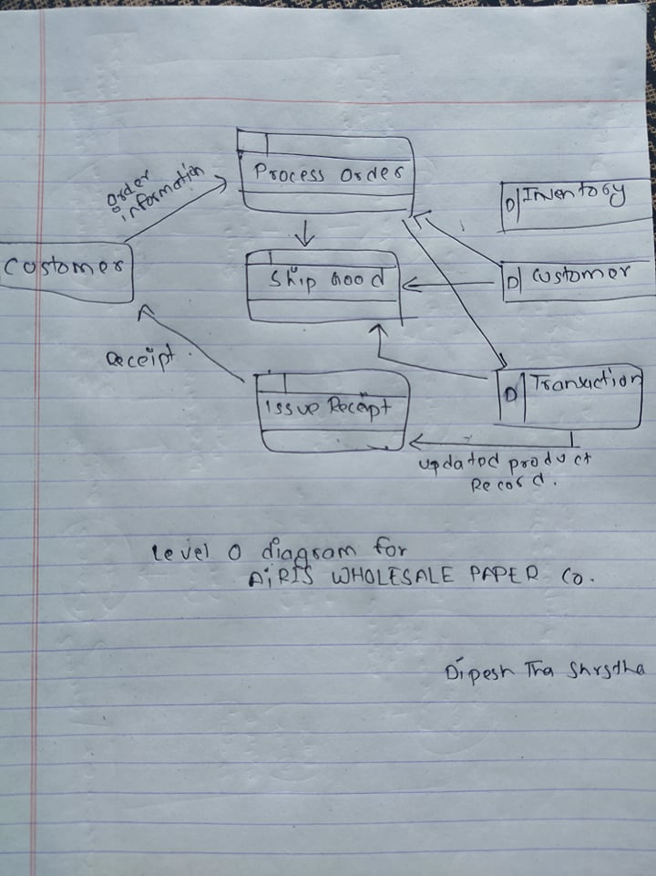

1. Differentiate between functional and non-functional requirement in the context of designing a software system?

Answer:

The differentiate between functional and non-functional requirement in the context of designing a software system is given below:

|  |  |  |
| --- | --- | --- |
| Parameters | Functional Requirement | Non-Functional Requirement |
| Objective | Helps you verify the functionality of the software. | Helps you to verify the performance of the software. |
| Area of focus | Focus on user requirement | Concentrates on the user's expectation. |
| Documentation | Describe what the product does | Describes how the product works |
| Type of Testing | Functional Testing like System, Integration, End to End, API testing, etc. | Non-Functional Testing like Performance, Stress, Usability, Security testing, etc. |
| Test Execution | Test Execution is done before non-functional testing. | After the functional testing |
| Product Info | Product Features | Product Properties |

1. Draw level 1 DFD for a Food Ordering System. Make your own assumptions wherever necessary

Answer

The level 1 DFD for a Food Ordering System is given below:

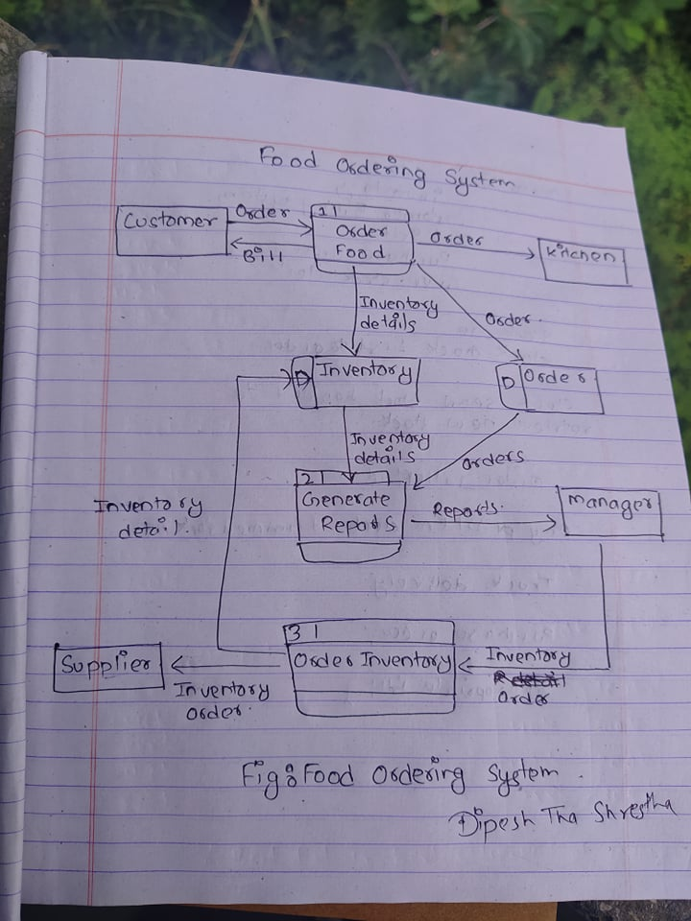

The Food Order System Data Flow Diagram example contains three processes, four external entities, and two data stores.

Based on the diagram, we know that a Customer can place an Order. The Order Food process receives the Order, forwards it to the Kitchen, store it in the Order data store, and store the updated Inventory details in the Inventory data store. The process also delivers a Bill to the Customer.

The Manager can receive Repots through the Generate Reports process, which takes Inventory details and Orders as input form the Inventory and Order data store respectively

The Manager can also initiate the Order Inventory process by providing Inventory order. The process forwards the Inventory order to the Supplier and stores the updated Inventory details in the Inventory data store.